

PRACTICAL -10
Hash Tables: Linear Probing, Chaining, and Double Hashing

Practical Aim
To implement hash tables using different collision handling strategies and develop the ability to reason about why collisions occur, how different strategies resolve them, and what trade-offs each approach involves.
Problem 1
A small parking lot has exactly 10 numbered slots (0 to 9). When a vehicle arrives, its registration number is used to assign it a slot by taking the last digit of the number. If that slot is already taken, the vehicle moves to the next available slot in order, wrapping around if necessary. Given a sequence of vehicle registrations, assign each to a slot using this rule and display the final state of all ten slots.
Describe what your solution does when it encounters an already occupied slot. What happens when the parking lot is nearly full and many vehicles keep landing on the same slot? Can you think of a situation where your solution might loop indefinitely?
CODE LINK:
https://github.com/nishee166/FDSA-Batch--B-SHP-.git

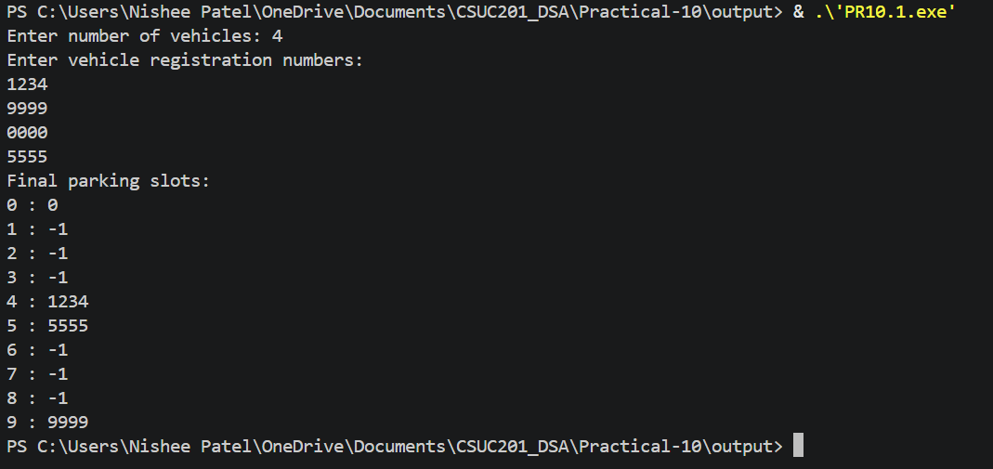
Error Faced:
I initially did not wrap around to slot 0 after reaching the last slot, so vehicles could not be placed in the earlier empty slots.
Learning:
I learned how linear probing resolves a collision by moving to the next free slot, and how clustering occurs.
Solution:
I used (index + 1) % SIZE to wrap around and added a counter to stop the loop when the table is full.

Problem 2
A library uses a system with 10 shelves numbered 0 to 9. Each book's code is used to decide which shelf it belongs to by taking the code modulo 10. Unlike the parking lot, each shelf can hold multiple books stacked together — when two books map to the same shelf, they are simply added to that shelf's stack. Given a sequence of book codes, place each on the correct shelf and display the final contents of all shelves.
Describe how your solution handles two books that map to the same shelf. What happens to search time on a shelf as more and more books pile onto it? Can you think of what would cause all books to end up on the same shelf?
CODE LINK:
https://github.com/nishee166/FDSA-Batch--B-SHP-.git
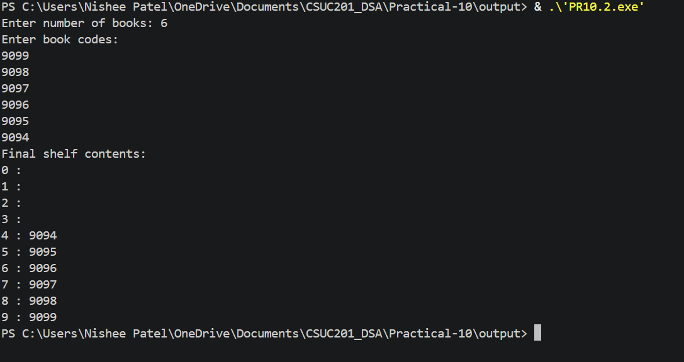

Error Faced:
I initially forgot to set every shelf to NULL at the start, so the program gave garbage values while printing.
Learning:
I learned how chaining stores multiple elements at the same index using a linked list.
Solution:
I initialised all shelf pointers to NULL before inserting any book code.

Problem 3
A university assigns student IDs to storage slots using a two-step rule. The first rule determines the initial slot. If that slot is taken, instead of simply moving one slot forward, a second rule based on the ID itself determines how many slots to jump. This means different IDs that collide will probe different sequences of slots, spreading them more evenly. Given a sequence of student IDs, assign each to a slot using both rules and display the final state of the table.
Describe how your solution decides how many slots to jump when a collision occurs. What is the risk if the jump size happens to be a factor of the table size? How does this strategy differ from Problem 10.1 in how it spreads collisions?
CODE LINK:
https://github.com/nishee166/FDSA-Batch--B-SHP-.git

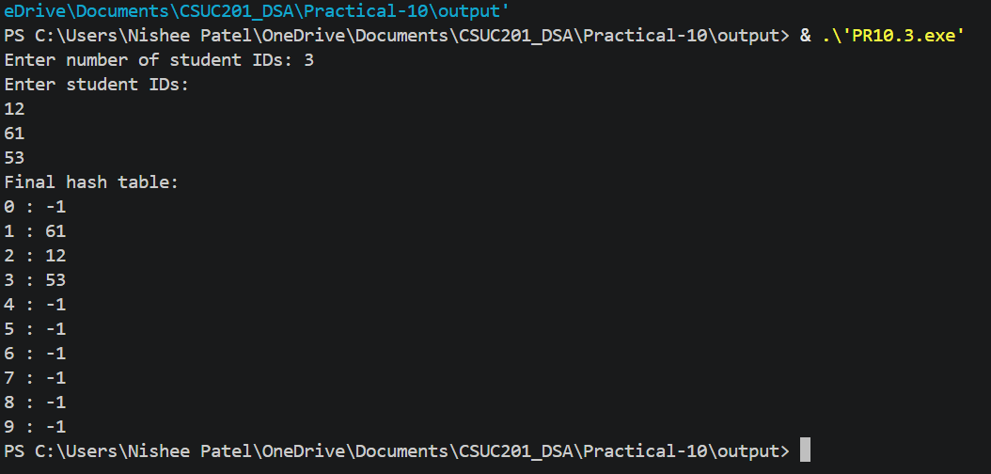

Error Faced:
I initially used a second hash function that could return zero, so the same slot was checked again and again.
Learning:
I learned how double hashing uses a second hash function to decide the jump size and spread the collisions.
Solution:
I changed the second hash function to 7 - (id % 7), which is never zero, and limited the number of probes to SIZE.
Key Questions:
Problem 1
If five consecutive vehicle registrations all end in the same digit, trace where each one gets placed in the parking lot. Now explain why this clustering effect is a structural weakness of this collision strategy — not just for this input, but in general.

ANS:
If five vehicles all end in the digit 3, they go to slots 3, 4, 5, 6 and 7 in order. The first takes slot 3 and each next one finds the previous slot full, so it moves one slot forward. This clustering is a structural weakness because a filled group of slots keeps growing, and any new vehicle that lands anywhere in that group has to travel to its end. This makes insertion and search slower, and it happens in linear probing in general, not only for this input.

Problem 2
Suppose all book codes in Problem 2 are multiples of 10. Without tracing through the code, predict what the final shelf layout would look like and explain why. What does this tell you about the relationship between the hash function and the input data?

ANS:
If all codes are multiples of 10, every code % 10 gives 0, so all books would be placed on shelf 0 and the other shelves would stay empty. Shelf 0 would become one long chain, and searching would become slow like a linked list. This shows that the hash function must suit the input data, because a poor match between them can ruin the performance.

Problem 3
In Problem 3, what would happen if the second rule always produced a jump size of zero? Trace through the consequence and explain how this failure is related to the choice of the second hash function rather than the data itself.

ANS:
If the jump size is always zero, then every probe checks the same slot again and again. If the first slot is occupied, the new ID can never be placed and the program would loop forever or fail. This is a problem of the second hash function and not of the data, because a good second hash function must never return zero and should be chosen so that it can reach all slots of the table.

Conclusion
The practical successfully implemented hash tables using linear probing, chaining and double hashing. I learned why collisions occur, how each strategy resolves them differently, and how clustering and a poor hash function affect the performance of a hash table.

